Core Clinical Services, Advanced Super-Specialties, Integrated Support Services



Oncology Cardiology Gastroenterology
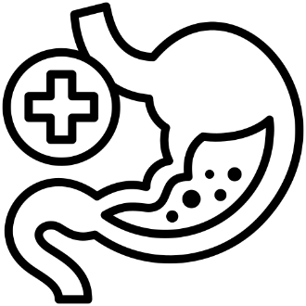

Neurology Urology Neuro Surgery


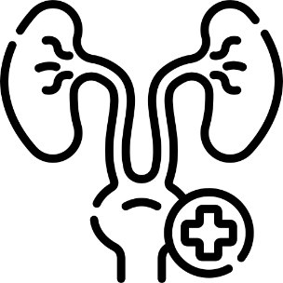

Assisted Reproduction – IVF Nephrology Otolaryngology


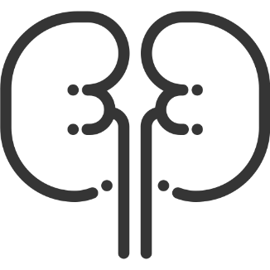

Paediatrics General Surgery Gynaecology



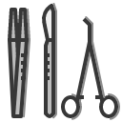


Internal Medicine Emergency Care Orthopaedics



Radiology Pathology labs Dental





Ophthalmology Psychiatry Pulmonology
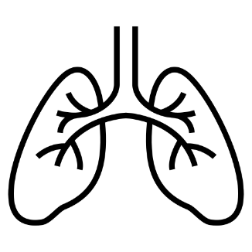



Laser Surgery Cardiac Sciences (CVTS) Neurosciences (Brain & Spine)

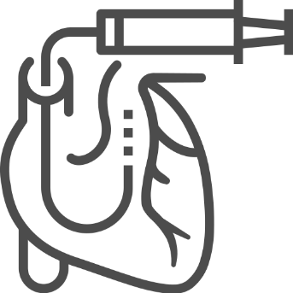


Nephrology Plastic Surgery Vascular Surgery
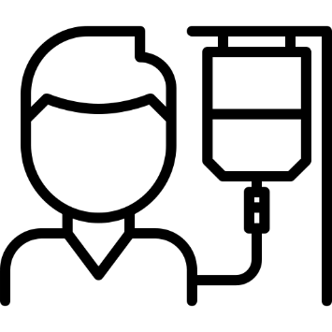
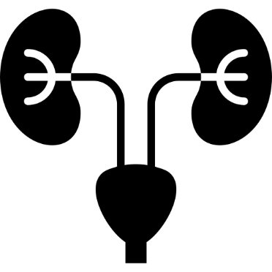


Paediatric Surgery Urology Arthroscopy

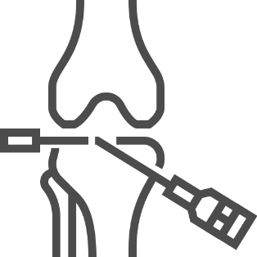
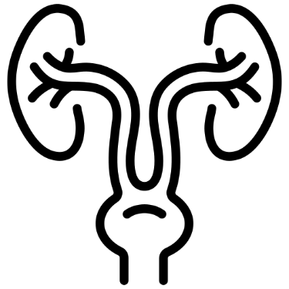

Joint Replacement Physiotherapy & Rehabilitation Dialysis

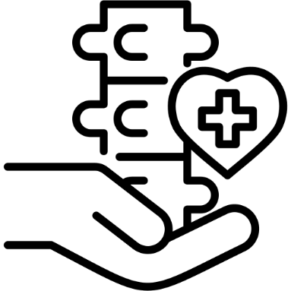
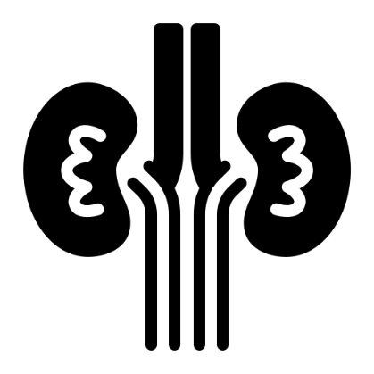

Blood Bank
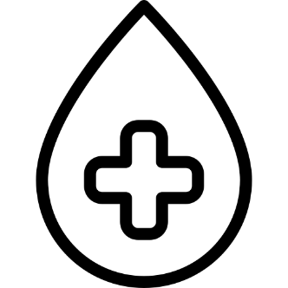

.ICO format icons
24/7 Emergency Care General Medicine Cardiology




Obstetrics & Gynaecology Paediatrics & Neonatology General Surgery




Orthopaedics & Trauma ENT (Otorhinolaryngology) Dental




Ophthalmology Dermatology Psychiatry






Pulmonology Laser Surgery

Oncology — Medical & Surgical Cardiac Sciences (CVTS) Neurosciences
(Brain & Spine)




Nephrology Gastroenterology (Liver / Biliary) Plastic & Reconstructive Surgery

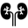


Vascular Surgery Paediatric Surgery Laparoscopic Surgery




Urology Arthroscopy Joint Replacement




Advanced Radiology & Imaging 24/7 Pathology (CCL) Physiotherapy & Rehabilitation




Anaesthesiology & Pain Management Dialysis Blood Bank




